Donation center Application

This application consists of 3 main entities: Donors, donation centers and doctors.

**DONORS:**

Donors mainly interact with donation centers, but are notified if diseases are found in their blood, if their blood is used in the treatment of a patient and if the Donation center runs out of blood and are required to donate again.

Donors also have the ability to specify if they want do donate blood to a certain person, if so, they must fill in the appropriate fields in the donation form.

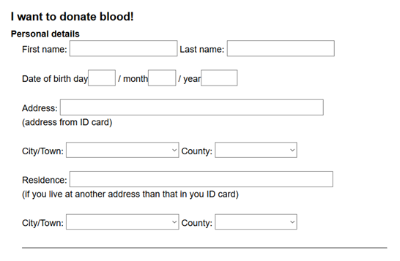

*Simple example of donation form

**DONATION CENTER:**

Donation centers receive donation forms donors. The donation process goes as follows:

Possible donor fills out donation form

Yes

Not fit for donation

Patient form signals problems?

No

Harvesting and separating the blood

Yes

Not fit for donation + Notify donor

Blood has diseases?

No

Blood is sent to storage

Donation centers also keep a list with all the donors.

Donation centers also receive request for blood from doctors. Requests from doctors contain an urgency indicator (ex: patient's state is critical, only for hospital storage), the blood component needed and the amount.

*Donation centers will also have a list of the personnel?*

Doctor requests go as follows:

Doctor requests blood component

Request is urgent?

No

Wait for the other requests to be fulfilled

Contact nearest donors

Yes

Is there enough blood in storage to fulfill the request?

No

Yes

Send blood to doctor

**DOCTORS**

Doctors have the ability to request blood from donation centers by filling request forms. Once the blood is received, the doctor will have to test it and the patients' blood for compatibility issues. If there are problems, the doctor will contact the donation center and send back the blood.

Send blood back?

No

Yes

Notify donor that they're blood has been put to good use

Blood types are compatible?

Blood arrives

Functional features:

Donors:

- Fill out forms for donations

- Specify if they want to donate for someone

- Keep track of their blood

Donation centers:

-Review current blood stocks

- Collect donor data

- Notify donors

- Manage donor list

- Process doctors' requests

- Contact nearest donor

Doctors:

- Review current blood stocks

- Fill in requests for blood

- Send compatibility results back to donation centers

- Notify donors

Non-Functional features:

Donation centers:

-find the nearest available donor